**One Punch Man Season 3: Release, Cast** 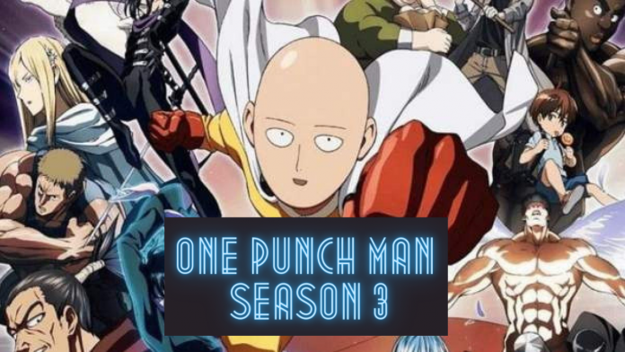

**One Punch Man season 3** is one of the most awaited anime series for which fans are waiting frantically since grand finale of season 2 was broadcasted in July 2019. It’s likely to take a fair amount of time for season three to be released because there was a gap of around 4 years amidst season one and two of **One Punch Man**. First season was premiered in 2015, and second in 2019, so it’s highly likely that season 3 will take a lot of time so that the creators of the series can work on it with more dedication and perfection and fans can have an unforgettable season.

**One Man Punch Season 3:** ***Cast***

The creators of the show has not yet commented upon the characters and the actors who has been casted for **season 3** but it’s highly anticipated that the actors from the last two seasons will be there along with few more characters and actors who’ll be joining the versatile cast members of One Man Punch anime series.

|  |  |
| --- | --- |
| Character | Voice Actor |
| **Saitama** | Makoto Furukawa |
| Genos | Kaito Ishikawa |
| **Garou** | Hikaru Midorikawa |
| Tatsumaki | Aoi Yuuki |
| Ymumen Rider | Yuuichi Nakamura |
| Eyelashes | Yoshiaki Hasegawa |
| Commentator | Hiromichi Tezuka |
| Bearded Worker | Shota Yamamoto |
| Bespectacled Worker | Ueda and Youji |

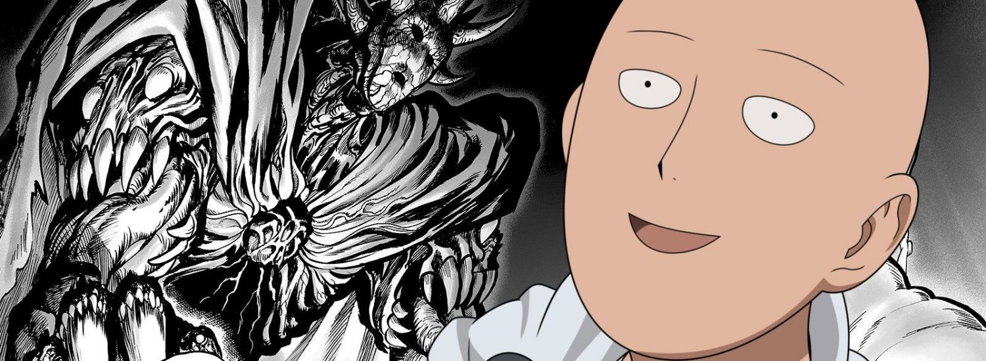

**One Man Punch Season 3:** ***Release Date***

It’s anticipated that **One Man Punch Season 3** will release by 2022. Main reason behind this delay is the time gap taken amid **season 2** and **season 1** premiere, so it’s highly likely that **season 3** release will also follow the same motif. Additionally, report says that covid-19 pandemic has immensely hampered the anime’s production. So, we hope to release it by 2022 but this’s just an expectation nothing is fixed as the makers of the show didn’t release any information about the same.

**One Man Punch Season 3:** ***Plot***

**One Man Punch** has a stunning plotline which leaves the fans bewildered and to have the yearning to see more of it.

The series revolves around a superhero **Saitama** who can get down anybody just by a single punch. He uses his ability to grapple monsters and demons. But we noticed that **Saitama** is always not taken care of to be guide and mentor to the other warriors because everyone judges on his skills. So, it’s highly likely that we’re going to see more of Saitama’s grapple to prove his adroitness. And it’s quite obvious that we’ll see more of Saitama’s skirmish shows.

Apart from that, there are expectations that One Punch Man Season 3 will pivot on Saitama and **Garou**’s conflict. So, it’s highly likely that we’ll see amazing brawls amid them. So, it’s going to be an action-packed season full of fascination.

Since the trailer for **season 3** has not been released yet. So, enjoy the trailer of **season 2😊** and stay

tuned to us for more latest updates!

https://www.youtube.com/watch?v=1u5KOogT-RI